Create two tables(like Employee--empId, name, zipcode) and Address table--(zipcode, city, country)Define joins with different types:  
Inner Join  
Left Join  
Right Join  
Full Join  
Cross join

**CREATE** TABLE LV_EMP2

(

EMP_ID **INT**,

EMP_NAME **VARCHAR**(100),

ZIP_CODE **VARCHAR**(15),

)

**CREATE** TABLE LV_ADDRESS

(

ZIP_CODE **VARCHAR**(15),

CITY **VARCHAR**(50),

COUNTRY **VARCHAR**(50)

)

SELECT * **FROM** LV_EMP2

SELECT * **FROM** LV_ADDRESS

INSERT **INTO** LV_EMP2 **VALUES**(1,'ANA','543214')

**INSERT** **INTO** LV_EMP2 VALUES(2,'JOHN','763214')

INSERT **INTO** LV_EMP2 **VALUES**(3,'SITA','873214')

**INSERT** **INTO** LV_EMP2 **VALUES**(4,'GITA','983214')

INSERT **INTO** LV_EMP2 VALUES(5,'RAM','123214')

**INSERT** **INTO** LV_ADDRESS **VALUES**('543214','BANGALORE','INDIA')

**INSERT** **INTO** LV_ADDRESS **VALUES**('543214','MUMBAI','INDIA')

**INSERT** **INTO** LV_ADDRESS **VALUES**('763214','MANGALORE','INDIA')

**INSERT** **INTO** LV_ADDRESS **VALUES**('873214','BANGALORE','INDIA')

**INSERT** **INTO** LV_ADDRESS **VALUES**('983214','CHENNAI','INDIA')

**INSERT** **INTO** LV_ADDRESS **VALUES**('123214','MANGALORE','INDIA')

1.INNER JOIN: Returns records that have matching values in both tables

**SELECT** EMP.EMP_ID,EMP.EMP_NAME,EMP.ZIP_CODE,AD.CITY,AD.COUNTRY

**FROM** LV_EMP2 **AS** EMP

**INNER** **JOIN** LV_ADDRESS **AS** AD

**ON** EMP.ZIP_CODE=AD.ZIP_CODE

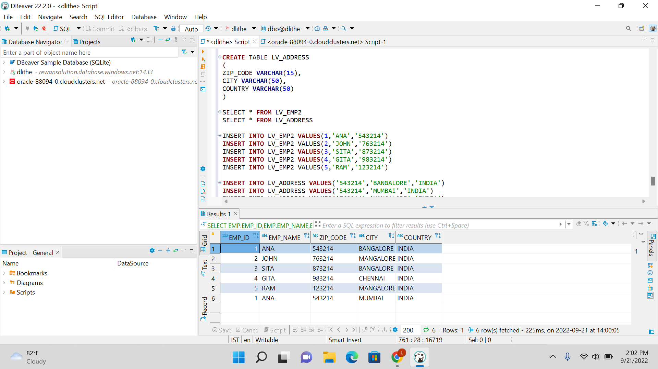

2. LEFT JOIN: Returns all records from the left table, and the matched records from the right table.

**SELECT** EMP.EMP_ID,EMP.EMP_NAME,EMP.ZIP_CODE,AD.CITY,AD.COUNTRY

**FROM** LV_EMP2 **AS** EMP

**LEFT** **JOIN** LV_ADDRESS **AS** AD

**ON** EMP.ZIP_CODE=AD.ZIP_CODE

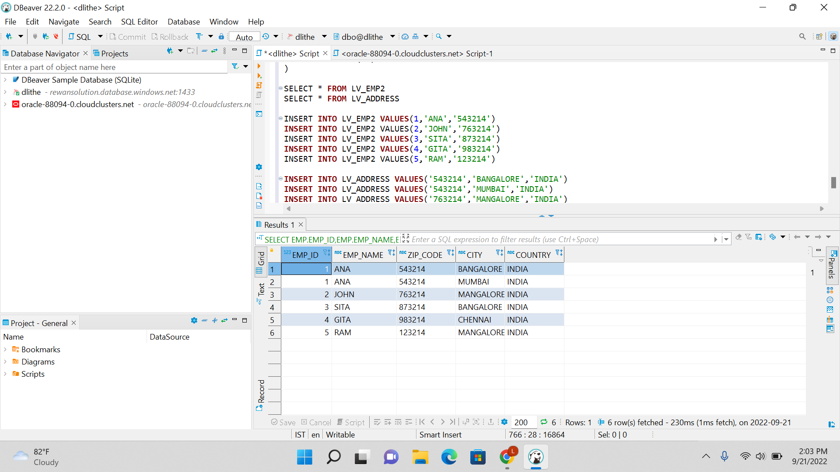

3. RIGHT JOIN: Returns all records from the right table, and the matched records from the left table.

**SELECT** EMP.EMP_ID,EMP.EMP_NAME,EMP.ZIP_CODE,AD.CITY,AD.COUNTRY

**FROM** LV_EMP2 **AS** EMP

**RIGHT** **JOIN** LV_ADDRESS **AS** AD

**ON** EMP.ZIP_CODE=AD.ZIP_CODE

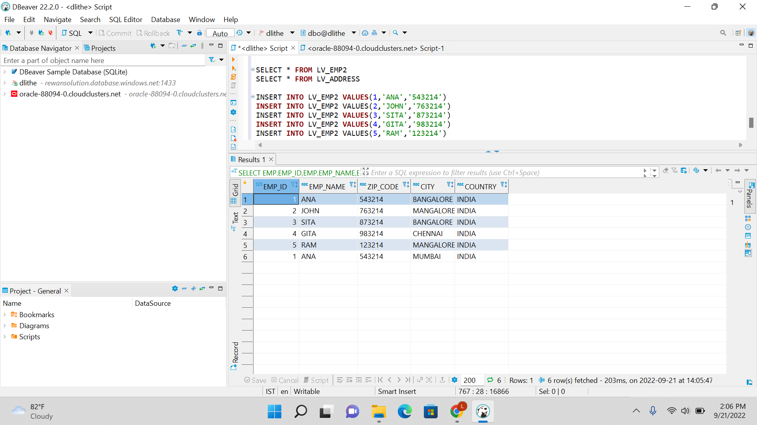

4. FULL JOIN: Returns all records when there is a match in either left or right table.

**SELECT** EMP.EMP_ID,EMP.EMP_NAME,EMP.ZIP_CODE,AD.CITY,AD.COUNTRY

**FROM** LV_EMP2 **AS** EMP

**FULL** **JOIN** LV_ADDRESS **AS** AD

**ON** EMP.ZIP_CODE=AD.ZIP_CODE

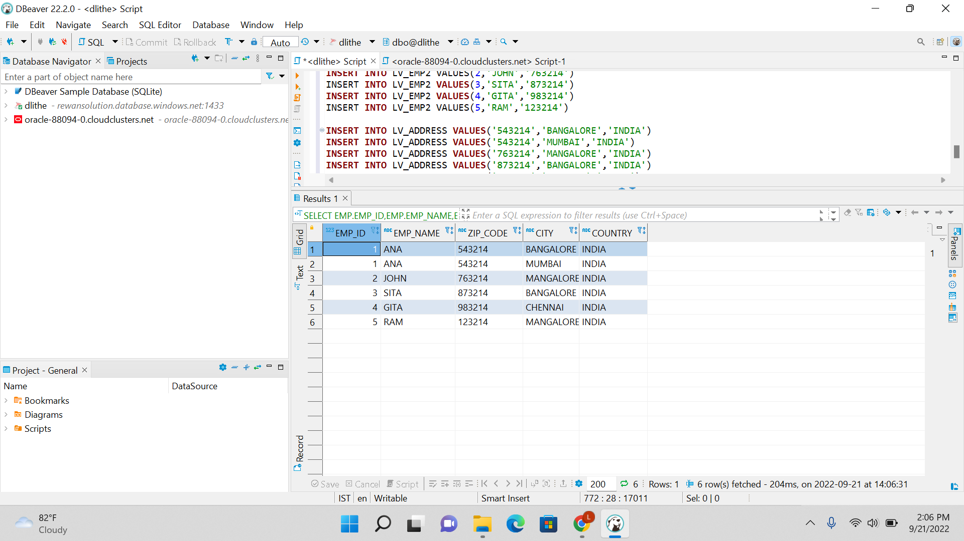

5. CROSS JOIN: Combines each row of the first table with each row of the second table.

**SELECT** EMP.EMP_ID,EMP.EMP_NAME,EMP.ZIP_CODE,AD.CITY,AD.COUNTRY

**FROM** LV_EMP2 **AS** EMP,LV_ADDRESS **AS** AD



